**Software Design Study and High-Level Design for JAMK Library System**

**1. Introduction**

**1.1 Purpose**

This document presents a study of available tools for software design and a high-level design for the JAMK Library System, based on the requirements specified in the Software Requirements Specification (SRS).

**1.2 Scope**

The document covers:

* A study of software design tools.
* Selection of appropriate tools for JAMK Library System.
* High-level architectural design, including UML diagrams.
* Technology stack recommendations.

**2. Study of Software Design Tools**

**2.1 UML and Architectural Design Tools**

* **Enterprise Architect**: Comprehensive UML modeling and architectural design tool.
* **Lucidchart**: Cloud-based diagramming tool for UML and system design.
* **Microsoft Visio**: Widely used tool for creating UML diagrams and process flows.
* **Draw.io**: Free, web-based diagramming tool for flowcharts and UML.
* **StarUML**: Lightweight UML modeling tool.

**2.2 Database Design Tools**

* **MySQL Workbench**: Visual database design tool for MySQL.
* **Microsoft SQL Server Management Studio**: Database management and design tool.
* **pgAdmin**: PostgreSQL administration and design tool.

**2.3 Code Generation and Development Tools**

* **Visual Studio Code**: Code editing and debugging tool.
* **JetBrains IntelliJ IDEA**: IDE for Java development.
* **Postman**: API development and testing tool.

**3. High-Level Design of JAMK Library System**

**3.1 System Architecture**

* **Frontend**: React.js (Web UI framework)
* **Backend**: Node.js with Express.js (RESTful API)
* **Database**: PostgreSQL (Relational database)
* **Authentication**: JAMK Authentication System (OAuth 2.0)
* **Hosting**: AWS or Azure

**3.2 UML Diagrams**

**3.2.1 Use Case Diagram**

* Actors: Students, Staff, Library Admins
* Use Cases: Borrow Book, Reserve Book, Extend Loan, Manage Inventory
* 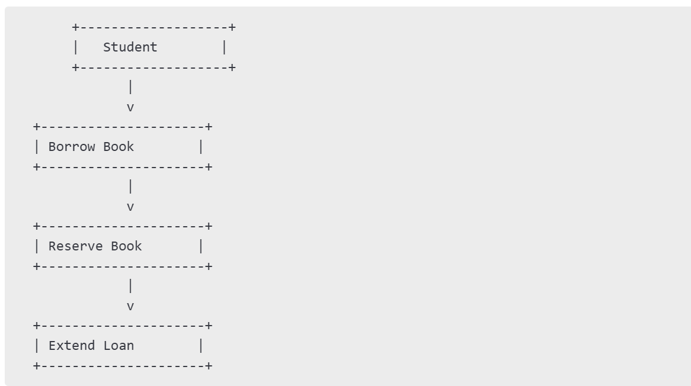

**3.2.2 Sequence Diagram**

* Sequence of interactions for book borrowing and returning.
* 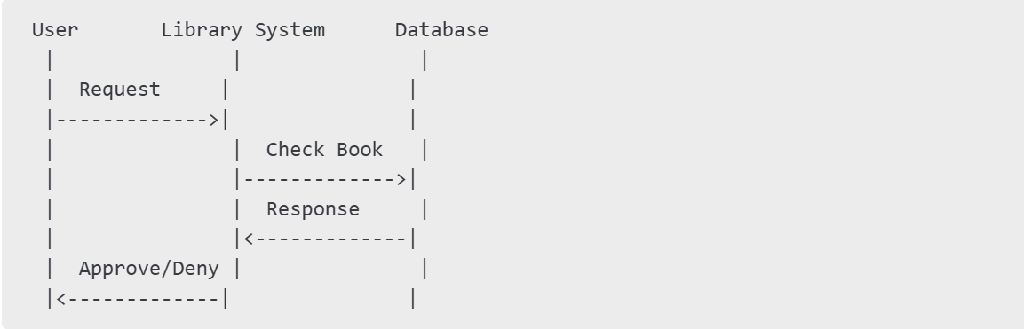
* 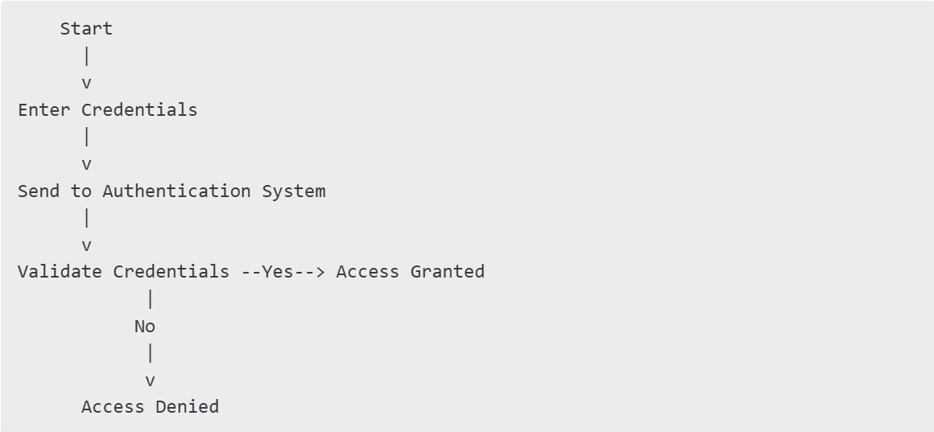

**3.2.3 Class Diagram**

* Main entities: User, Book, Loan, Reservation, Admin
* 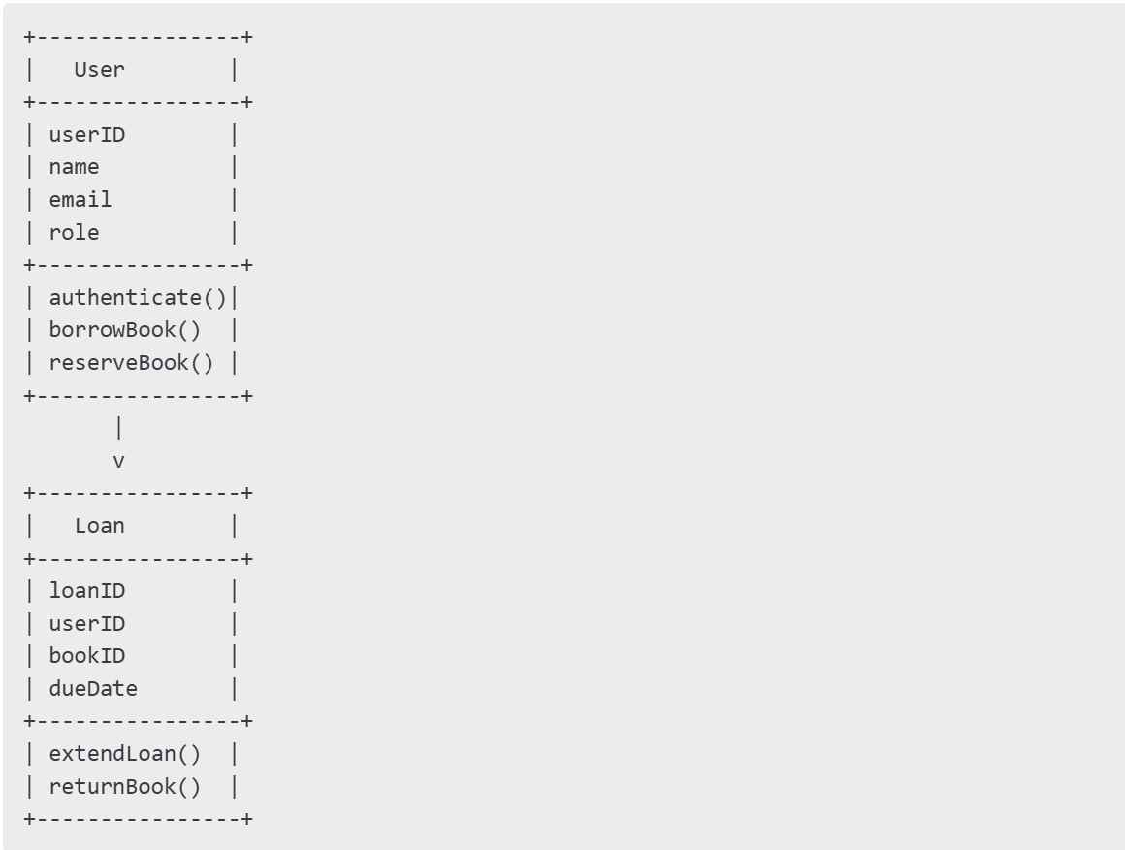

**3.3 Database Design**

* **Tables**: Users, Books, Loans, Reservations
* **Relationships**: One-to-Many (User to Loans), Many-to-Many (Users to Books via Reservations)

**4. Conclusion**

The study identifies appropriate software design tools, defines a high-level system architecture, and presents UML diagrams for the JAMK Library System. The proposed solution ensures scalability, security, and usability.

**5. References**

* JAMK IT Security Policies
* GDPR Regulations